**AGGREGATE DEMAND AND SUPPLY**

What causes recessions? Why is inflation high in some recessions and not others?  
The economy’s behavior can be explained, predicted, and potentially manipulated by looking at:

* **total (aggregate) demand.**
* **total (aggregate) supply.**

The **AD-AS model** is useful to understand what causes recessions and how they can be handled. The economy’s behaviour can be explained, predicted, and potentially manipulated by looking at **total (aggregate) demand** and **total (aggregate) supply.**

Aggregate Demand Curve

The **aggregate demand curve** illustrates the **relationship** between the **aggregate price level** (GDP deflator 🡪 ratio between nominal and real GDP) and the quantity of **aggregate output demanded** (real GDP) by households, businesses, the government and the rest of the world. It is the relationship between GDP and the real level of prices.

2005 is the base year taken into consideration. The curve has a negative slope, so the two variables are in a negative relationship.

The Shape of the A.D. Curve:

Since GDP = C + I + G + X – IM, why does a rise in the aggregate price level reduce C, I, and X − IM? So, why does the AD curve have a negative slope? There are two reasons:

* **Wealth effect:**a higher aggregate price level **reduces the purchasing power** of households’ wealth and reduces consumer spending.
* **Interest rate effect:**a higher aggregate price level makes households hold more money and leads to a rise in interest rates and a **fall in investment spending** and consumer spending.

The Aggregate Demand Curve and the Income-Expenditure Model

Keynesian cross is a graphical representation between real GDP and Planned Aggregate Spending

Only in E1 real GDP corresponds to planned aggregate spending. However, **if we drop the assumption that prices are fixed** (they now can change), when prices decrease planned aggregate spending increases, since it is the sum of consumption spending and planned investment. If the general level of prices decreases, there is an increase in consumption and an upward shift in the AEplanned curve and a new equilibrium with a greater real GDP and a higher price. How does it relate to the AD curve?

**If the price level drops, planned spending rises at all output levels** (from the wealth and interest-rate effects). This leads to a multiplier process that moves the income-expenditure equilibrium from E1 to E2 and raises real GDP from Y1 to Y2.

General Level of prices decrease 🡪 Shift up of the curve 🡪 new I-E. eq (E2)🡪 Greater Real GDP 🡪 Increase in Income 🡪 Increase of purchasing power🡪 Increase in consumption 🡪 New equilibrium

The AD curve is a graphical representation of all potential equilibriums in the income-expenditure model at different prices. This also explains why the AD curve slopes downwards.

Shifts of the Aggregate Demand Curve:

What are the exogenous sources of variations in the AD curve? The aggregate demand curve shifts because of changes in:

* **Expectations:** Consumers base their spending not only on current income but also on future income. Firms base their planned investment spending not only on current conditions but also on the sale they expect to make in the future.
* **Wealth:** Consumer spending depends in part on the value of household assets; when it rises, the purchasing power they embody rises as well.
* **Size of the existing stock of physical capital:** Firms engage in planned investment spending to add to their stock of physical capital. Their incentive to spend depends in part on how much physical capital they already have. The more is the physical capital they already have, the less they will feel a need to add more, other things equal.
* **Government policies:**
* **Fiscal policy:** fiscal policy is the use of either government spending (government purchases of final goods and services and government transfers) or tax policy to stabilize the economy.
* **Monetary policy:** the quantity of money in circulation is largely determined by the decisions of a central bank created by the government. When the central bank increases the quantity of money in circulation, households and firms have more money, which they are willing to lend out, driving the interest rate down. This leads to higher investment spending and higher consumer spending.

The **Short-Run** Aggregate Supply Curve

The **AS curve** represents the relationship between the **aggregate price level** and the **quantity of aggregate output in the economy**. It has a positive slope because there is a positive relationship between the two variables.

Why does the short run **AS curve slopes upwards**? When aggregate price level change, also wages should be included in this change. So how is it possible to have a positive relationship?   
**Wage is also a price**, when the Aggregate Price Level changes the wage should be included in change. Furthermore, it is due to the **sticky wages**, namely nominal wages that are **very slow to adjust** in the short run if there is unemployment or labour shortages.

* **Nominal wage:** the dollar amount of the wage paid. Usually employers and employees establish this kind of wages.
* **Sticky wages:** nominal wages that are slow to fall even in the face of high unemployment and slow to rise even in the face of labour shortages.

How do sticky wages affect SRAS?   
Most of the agreements in this fields agree on a salary that last for at least one year, independently from the fact, the level of prices will change or not.

▪ Profit per unit of good = Price Per Unit - Cost Per unit   
Nominal wages are often determined by contracts that were signed some time ago. Even when there are no formal contracts, there are often informal agreements between management and workers.

If we consider **profit per unit**, namely the **difference** between **price per unit** and **production cost per unit**, if wages are sticky price per unit increases but production costs stay fixed, so the difference results in a higher level of profit per unit.

Therefore, a higher aggregate price level leads to higher profits and increased aggregate output in the short run.This holds only in the short run, since in the long run also nominal wages will adjust.

When the general level of prices increase in the **short run** 🡪 also profits per unit increases 🡪 incentive to increase production 🡪 affects positively the real GDP 🡪… 🡪In the **long run** wages will adjust

However, many firms are in very competitive industries, so they have no control over price. Some aren’t—and can raise price when demand is strong. (more support for the positive slope of the SRAS)

Shifts of the **Short-Run** Aggregate Supply Curve

What happens when something changes production levels at every price level? The SRAS curve shifts because of changes in:

* **Commodity prices:** if they decrease the SRAS will shift rightwards, whereas if they increase there will be a negative shock in SRAS (shift leftwards).
* **Nominal wages:** if they decrease the SRAS will shift rightwards and if they increase it will shift leftwards.
* **Productivity:** if it increases the SRAS will shift rightwards and if it decreases it will shift leftwards.

Each of these factors changes producers’ profits and therefore shifts the SRAS.

The **Long-Run** Aggregate Supply Curve

The **long-run aggregate supply curve** shows the **relationship** between the **aggregate price level** and the quantity of **aggregate output supplied** that would exist if **all prices**, including nominal wages, were fully **flexible**.

It is a measure of the potential level of output that could be produced in an economy in a given period. The long run is the time it takes for all prices (including nominal wages) to adjust.

Now there is no change to profits simply because prices have changed. It is represented by a vertical line corresponding to a level of output/real GDP called **potential output** that the economy would produce if all prices were flexible and all the resources were efficiently used.   
**Potential Output**: ***output*** is the level of real GDP the economy would produce if all prices, including nominal wages, were fully flexible and all the sources are ideally used

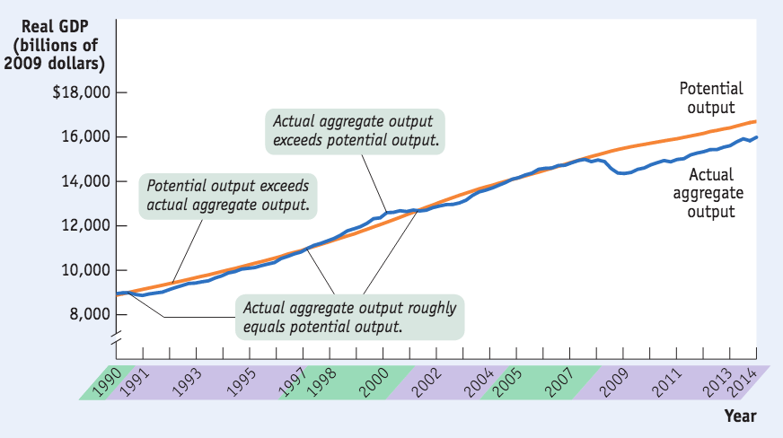Actual and Potential Output:

Observing real data, we notice that real output is always either above or below potential output because of short run fluctuations. The difference between the two curves is the inflationary gap (actual < potential) or recessionary gap (actual > potential)

How are the SRAS and the LRAS linked?

[FIRST PICTURE] Assume that in the short period the economy is in A1, so we are in a recessionary gap because **aggregate output supplied exceeds potential output** (temporarily). Eventually, low unemployment will cause nominal wages to rise and SRAS will shift left.

[SECOND PICTURE] Consider the opposite situation: **actual output** is **below potential output** and aggregate output supplied falls short of potential output (temporarily). Eventually, since in the long run wages are free to move, high unemployment will cause nominal wages to fall, and SRAS will shift right up to the point in which actual and potential output correspond.

The AD-AS Model

The **AD-AS model** uses the aggregate supply curve and the aggregate demand curve together to analyze **economic fluctuations**.  
  
Shifts of Aggregate Demand: **Short-Run** Effects

What happens if there is a **NEGATIVE demand** shock (total spending falls)? The AD curve will shift leftwards and a new short run equilibrium will be established with a higher level of unemployment but lower aggregate price level and real GDP.

If there is **a POSITIVE demand shock** (total spending rises), the AD curve will shift rightwards and a new short run equilibrium will be established with a lower level of unemployment but higher aggregate price level and lower real GDP (inflation).

Shifts of the SRAS Curve:

If there is a **positive shock in the supply** side (total production increases at every price level), prices will decrease, output will increase and there will be lower unemployment (ideal situation).

If there is a **negative shock in supply**, there is a lower aggregate output and a higher aggregate price level, but also low unemployment: this is the worst situation, difficult to handle.   
It is called **stagflation**: the combination of inflation and falling aggregate output that comes with a negative supply shock.

The Long-Run Macroeconomic Equilibrium

The economy is in **long-run macroeconomic equilibrium** when the point of short-run macroeconomic equilibrium is on the long-run aggregate supply curve.   
Let’s consider an economy which is in both short run and long run equilibrium:

If a demand or supply shock hits the economy, *AD* or *SRAS* shifts and moves the economy to a new short-run equilibrium.

[FIRST PICTURE] For example, consider a **short-run negative demand shock**: there is a **recessionary gap**, namely a situation in which real GDP (aggregate output) is lower than the potential output.

[SECOND PICTURE] On the contrary, if there is a **positive demand shock** we are in an inflationary gap, namely a situation in which the aggregate output is above the potential one.

Gap Recap:

**Recessionary gap**: When aggregate output is below potential output

**Inflationary gap**: When aggregate output is above potential output

**Output gap** is the % difference between actual aggregate output and potential output

$$Output gap=\frac{Actual aggregate output – Potential output }{Potential output}×100$$

**What happens next? Are we stuck in a gap forever?**  
Policy makers can attempt to move us back to potential output next…But the economy may correct itself in the long run if wages and prices fully adjust.

Short-Run VS Long-Run Effects of a Negative Demand Shock  
Consider a **recessionary gap**: the economy is producing less than the potential output, so it is not using all the resources and employment is not exploited at its maximum (high **unemployment** rate) and this causes a **reduction** of **nominal wages** in the long run. If there is no government intervention, this results in a positive shock in the short run aggregate supply curve, which will shift rightwards. We are eventually in a new macroeconomic equilibrium with a level of aggregate output corresponding to the potential one and lower price level.

Short-Run VS Long-Run Effects of a Positive Demand Shock  
If there is a positive shock in demand, there will be a new short run macroeconomic equilibrium (E2) corresponding to an inflationary gap, with a **low unemployment** rate (cyclical unemployment 🡪 potential employees looking for a job even for lower wages but not finding it because the system is producing less) and a high demand for workers. Without government intervention, this will push up nominal wages, leading to a negative shock in the short run aggregate supply curve and to a new macroeconomic equilibrium with an output corresponding to the potential one and a higher price level.

**Macroeconomic Policy**

In the long run, the economy is capable of reaching a macroeconomic equilibrium, yet most economists think it takes a decade or more to do it. To reduce times, it is possible to implement **stabilization policies**, namely the use of government policy to reduce the severity of recessions and rein in excessively strong expansions. John Maynard **Keynes** (1883–1946) created the modern field of macroeconomics.

*“But this long run is a misleading guide to current affairs. In the long run we are all dead. Economists set themselves too easy, too useless a task if in tempestuous seasons they can only tell us that when the storm is long past the ocean is flat again”*  
(J. M. Keynes)

Responding to Supply ShocksNegative supply shocks pose a policy dilemma:

To **stabilize aggregate output** requires increasing aggregate demand. This will lead to inflation.

But to **stabilize prices** requires reducing aggregate demand. This will deepen the output slump.